I find a problem is that when I rerun the app, the follower is not exactly the same with before.( 就是说， 你重启app， 你会发现你follow的人变了， 这个变指在你app中显示的，后台数据是没变的)

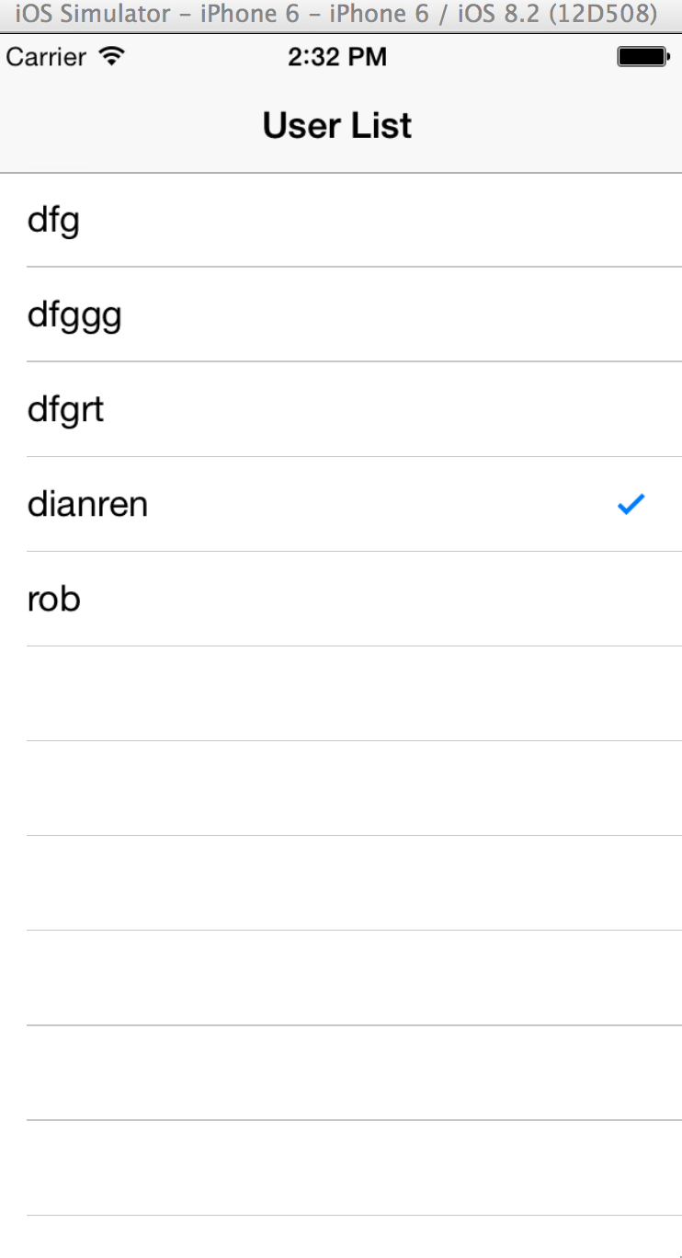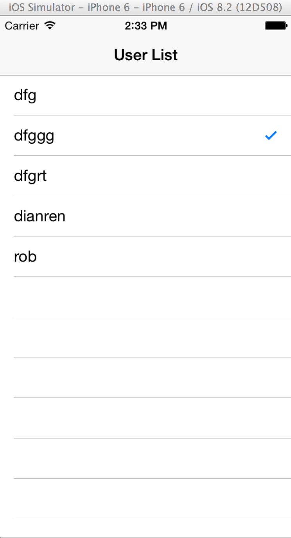

before after rerun

what’s the problem ?

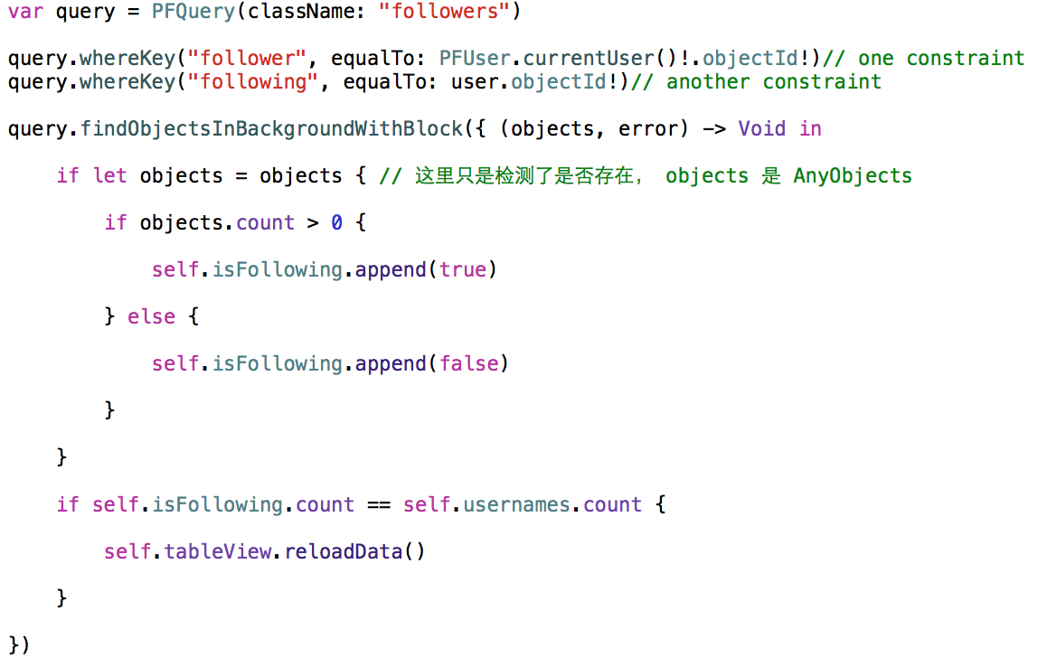

This query find the objects in block is not necessarily happens in order! It happens in random order.

Use dictionary :

var isFollowing = [“”: false]

